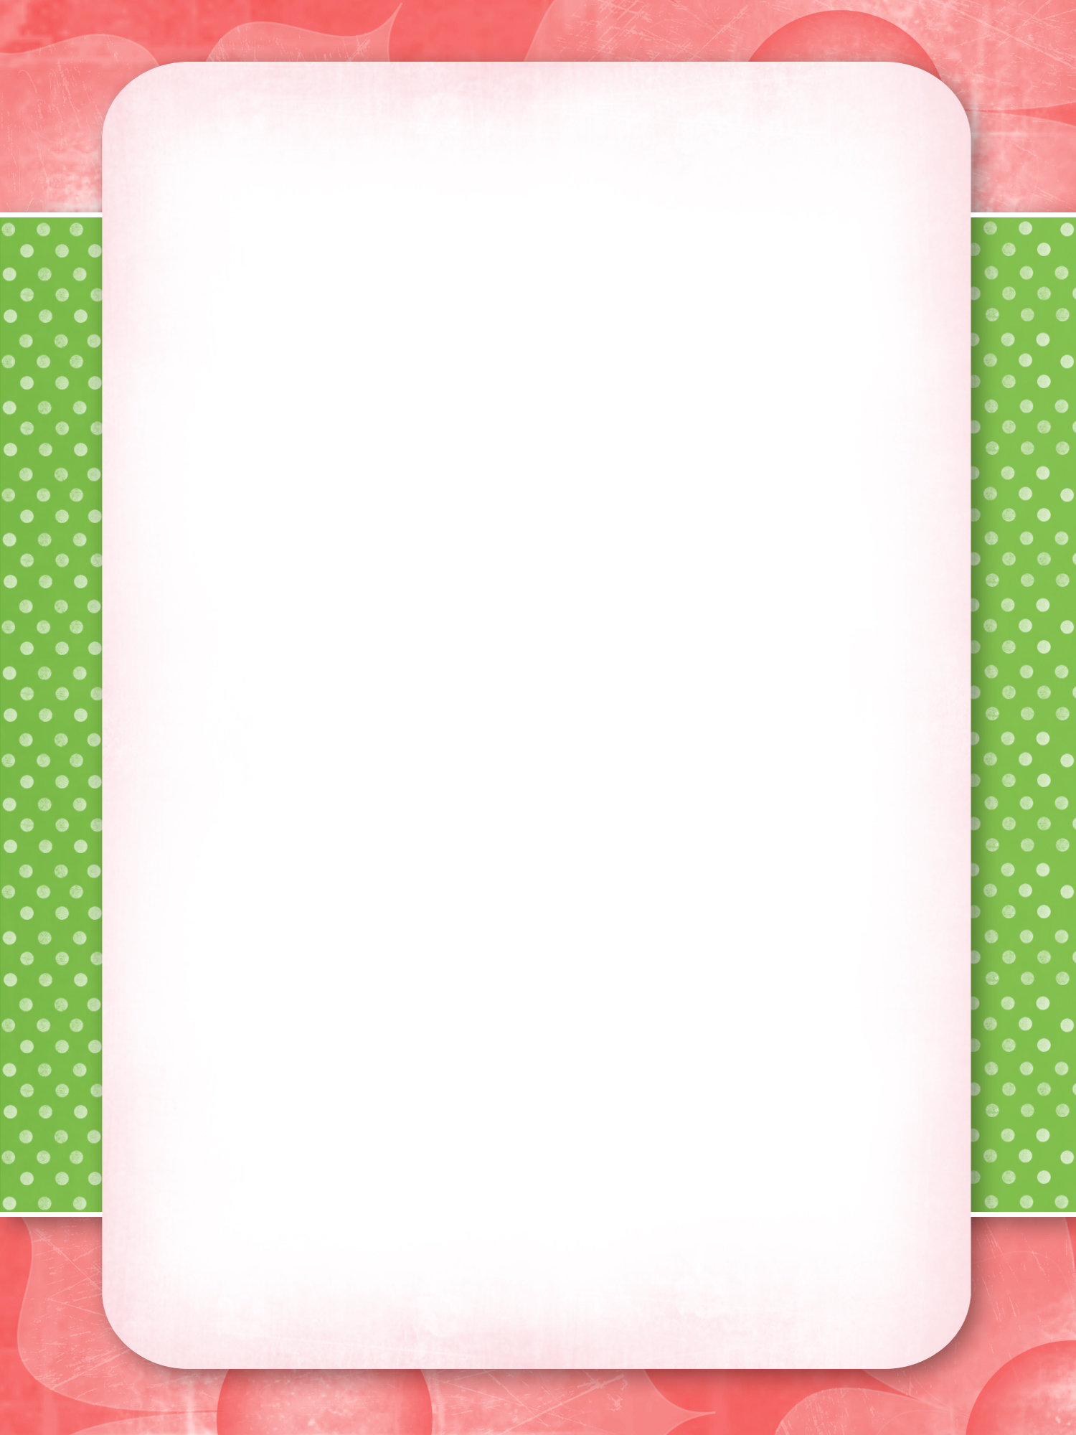
Private Party
Menu

Choice #1
$32.50
Appetizer- Burchetta,eggplant, zucchini .
Salad- House
Main Dish- –Any Three from our pasta, chicken dishes.
Dessert –cannoli, creme burlee,spumoni .
Homemade garlic rolls & soft beverages are included.

Choice #2
$38.50
Appetizer-Burchetta,Mozzerella,Calamari.
Salad- House
Main Dish- Your choice of any four dish from . Pasta,Chicken,Veal&Seafood.
Dessert- Any three dessert of your choice
Homemade Garlic Rolls ,&soft beverages included
$15 for kids (6-13)
Tax and gratuity not included in above prices

